serving Jesus

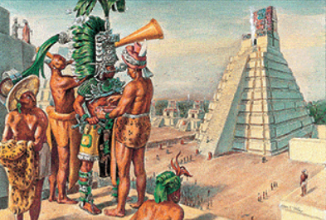 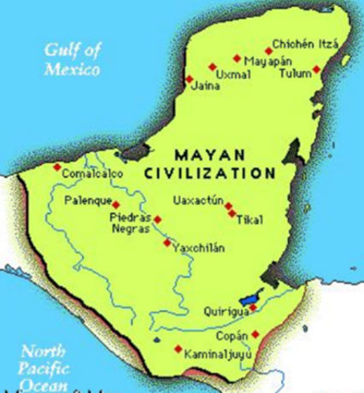

Summer 2025 Year 6

Topic: Mayans

**Topic:**

The Mayans and Mayan Empire-We’ll be examining this fascinating empire – where it was, what it was made up of and how they lived. We’ll be doing map work to further our knowledge.

Literacy:

We’ll be looking at ‘Rainplayer’ in literacy sessions. In Guided Reading we’ll be continuing practicing answering questions using reading gems.

**RE:**

How and Why Should Religious Communities do more to Care for the Earth?

**PE and Music:**

**PE: Athletics**

**Music: Celebrations**

**ICT:**

**Spreadsheets**

**Using spreadsheets for presenting Data**

**Film Making**

**Using ICT to make our own films!**

**Numeracy:**

We will be following the Maths No Problem and will complete this. After SATs, we will be doing a maths project linked to the world of work.

**Science:**

**Animals (Including Humans)**

**The Human Body, including blood, the circulatory system, the heart, and other essential organs**

**We’ll be looking at how these fundamental parts of the body work and conducting investigations!**

**Drama/S&L Opps:**

Children to share their views about traditions in other countries.

Children to present their findings about specific topics for the countries we are studying.

Giving own views and listening to others views about wealth and poverty.

Debates about Graffiti.

Debate about deforestation

**Writing Opportunities:**

**Biography**

**Recounts**

**Narrative pieces**

**Description**

**Character work**

**Explanation texts**

**Languages: Children will be learning French and practicing sentences and pronunciation.**

**Our topics will be clothes and habitats.**

**Art /DT:**

Pop Art – Looking at famous pop artists – Warhol/Lichtenstein – before creating our own pieces inspired by them!

DT-South American food and Smart watches

Clay work – Making our own Mayan Calendars