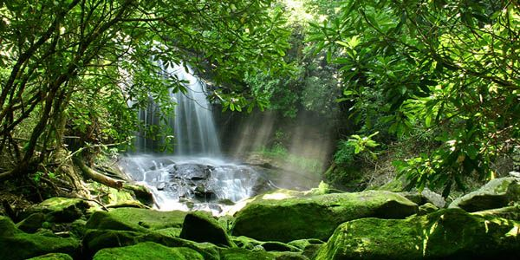

**Questions children want to investigate:**

What animals live in the rainforest?

What type of trees are in the rainforest?

What is the temperature in the Rainforest?

What is the size of the rainforest?

How often does it rain?

Do humans visit the Rainforest for holidays?

What insects live in the Rainforest?

Are there any poisonous creatures in the Rainforest?

How long could a human survive in the Rainforest?

How many types of snakes live in the Rainforest?

0

**Humanities**

**Geography Focus:**

**Focus – Non European Contrasting Location - South America**

Lines of latitude / longitude

Rainforest weather report

Name/locate S American countries

Brazil / UK comparison – human and physical Geography

**Rainforests and Habitats Year 4**

Summer 2025

**Art /DT:**

**DT** – Sewing creatures of the rainforest

**Art –**  South American art and natural printing.

**RE:**

Children will be following our scheme and exploring:

What can we learn from Religions About Deciding what is Right and Wrong?

**PSHCEE:**

Keeping Safe

BV – Mutual Respect, Tolerance for Diversity and Individual Liberty

BV – Respect for Diversity and Individual Liberty

**Maths: Maths – No problem!**

This Term’s topics will be:

* Fractions
* Shape, space and measure, including time
* Money

As well as this we will continue to practise our times tables, basic skills and reasoning every day.

**Writing Opportunities:**

This term we will continue to write in a variety of genres including:

Extended stories

Information texts – rainforests

Texts inspired by the rainforest

We will also continue to practise our basic skills in all our lessons.

**PE and Music:**

**Swimming:** lessons continue **every Friday**.

**PE**: is every Thursday and will cover orienteering, basketball and athletics

**Music:** Group Ensemble Performance – recorders and other aspects such as singing and composing

**Computing:**

Our focuses this term will be:

* Communication – email and blogging
* Creating animations

**MFL**

We will continue to learn French and phrases for In the classroom and At the tea room.

**Science:**

Living things and their Habitats

Materials & their properties