Topic: Year 5 Magical Monarchs – Summer 2025
Topic:
History:
Kings and Queens throughout history, timelines
Elizabeth I and Victoria
Geography
The UK, human and physical geography, cities, counties, mountains, rivers

Numeracy:
Percentages
Geometry
2D and 3D Shape
Position and Movement
Measurement
Area and Perimeter
Volume

Writing Opportunities:
- Persuasive writing about a well-known bird.
- Descriptive writing
- Informal persuasive writing
- Motivational writing

RE:

What can be done to reduce racism?
Can religion help?

ICT:
Cre8 IT
Graphical
modelling
Cre8 IT
Photostories

Science:
Animals including Humans
Living things and their habitats

PE
Dance and Gym: Athletics –
Olympic Training Striking and Fielding

Drama/ Speaking & Listening
- hot seating famous
people for biographies.
-Drama and role play
-Reading play scripts

Music:

- At the Movies
- Celebration

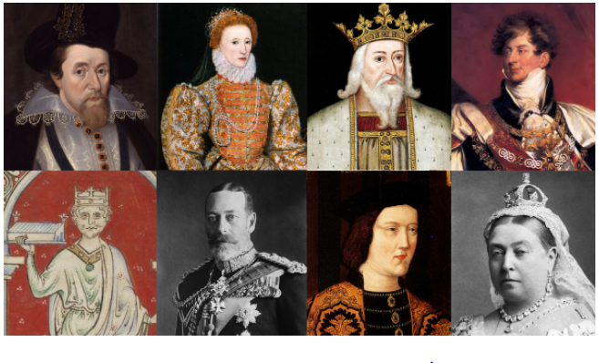
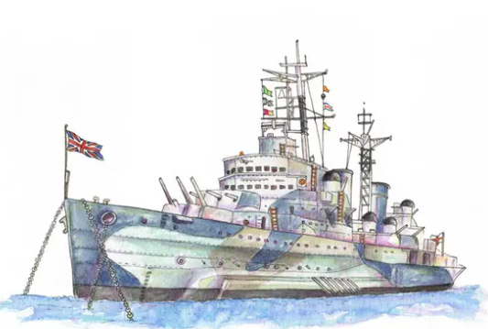Time to Kip on a Ship!

