
Before We Leave, We Will Achieve…..
 | 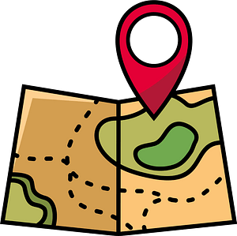  EXPLORING OUR WORLD & BEYOND OUR LOCAL AREA  (TRIPS & VISITS TO PLACES OF WORSHIP) |   TIME TO SHINE  (TAKE PART IN A PERFORMANCE) |   IT’S ART!  (WATCH A PERFORMANCE; WORK WITH AN ARTIST; VIEW ART) |   IN IT TO WIN IT  (ENTER A COMPETITION) |   ENTERPRISE & THE WORLD OF WORK  (UNDSTG MONEY MANAGEMENT & ENTERPRISE PROJECTS) |   NURTURE & RESPONSIBILITY (SENSE OF RESP FOR SELVES & WHERE THEY LIVE- EG CARE FOR A PLANT/S, ANIMALS) |   HELPING HAND  (SERVING SCHOOL & WIDER COMMUNITY- EG SCHOOL COUNCIL, MONITORS, PREFECTS, LITTER PICKS ETC)
NURSERY | Visits to St Clements Church  Welly walk around school ground  Trip to the local park  Transport survey  Trip to a farm  Caterpillar to butterfly metamorphosis  Trip to Zoo  Aut/Winter – firepit in forest school lead up to bonfire night. Toasted marshmallow and bonfire story | Nativity  End of year performance  Mouse Club  Awards ceremonies | Watching Christmas pantomime & KS1 Nativity  Watching Drama club performance | Christmas hat parade  Easter bonnet competition | Welly walk- sponsorship  Non uniform fundraising  Macmillan coffee morning | E-safety  Road & water Safety  Lifecycles  Feeding birds  Healthy Lifestyle Week | Visiting the elderly  Donating uniform  Being a classroom monitor  Sue L and Sue N – Bible stories
RECEPTION | Visits to St Clements Church- one trip to look around and for church services e.g. Christmas, Easter, Reception Welcome Service etc  Autumn welly walk around local park.  Walk to local shop/supermarket.  Trip to a Castle  Another trip or visit | Nativity  Class assembly- Summer 2  Awards ceremonies | Watching Christmas pantomime & KS1 Nativity  Watching Drama club performance | Christmas hat parade  Easter bonnet competition | CLEMS points- learning that if they save their points they will get better prizes  Welly walk- sponsorship  Non uniform fundraising  Macmillan coffee morning  People Who Help Us- world of work | E-safety  Road & water Safety  Growing plants in class  Lifecycles | Visiting the elderly  Walk to the church and meet the clergy. Rev Paul to meet the chn. Visitor during Harvest. (see food displayed – walk to hall)  Helping to tidy after Nursery stay and play  Donating uniform  Being a classroom monitor  Litter Picking & recycling

