Pupil premium strategy statement 2025-26

This statement details our school’s use of pupil premium funding to help improve the attainment of our disadvantaged pupils.

It outlines our pupil premium strategy, how we intend to spend the funding in this academic year and the effect that last year’s spending of pupil premium had within our school.

School overview
Detail | Data
School name | St Clements C of E Primary
Number of pupils in school | 234 inc 20 Nsy as at 09.09.25
Proportion (%) of pupil premium eligible pupils | 56.4% no Nsy
Academic year/years that our current pupil premium strategy plan covers (3 year plans are recommended) | 2025-2026
Date this statement was published | 23rd September 2025
Date on which it will be reviewed | July 2026
Statement authorised by | Eleanor Ward- Chair of Governors
Pupil premium lead | Jane Parker- Head Teacher
Governor lead | Tony Daly- PPG link governor
Funding overview
Detail | Amount
Pupil premium funding allocation this academic year | £3,563.00 EYFS (01/09 – 31/03)  £TBC EYFS (01/04 -  31/08)  £71,225.00 R - Yr6 (01/09 – 31/03)  £TBC R - Yr6 (01/04 -  31/08)
Pupil premium funding carried forward from previous years (enter £0 if not applicable) | £3,642.00 – this was due to receiving additional grants
Total budget for this academic year | £TBC EYFS (01/09-31/08)  £TBC R – Yr6 (01/09- 31/08)  £3,642.00 bought forward  TOTAL £TBC

Part A: Pupil premium strategy plan

Statement of intent
Our intention is that all pupils, irrespective of their background or the challenges they face, make good progress and the majority achieve age related or higher attainment across all subject areas. The focus of our pupil premium strategy is to support disadvantaged pupils to achieve that goal, diminishing the difference between their non-disadvantaged peers, including progress for those who are already high attainers.
We are aware of the challenges faced by vulnerable pupils and their families, such as those who have a social worker or are living in deprivation. The activity we have outlined in this statement is also intended to support their needs, regardless of whether they are disadvantaged or not.
Quality first teaching is at the heart of our approach, with a focus on areas in which disadvantaged pupils require the most support. This is proven to have the greatest impact on closing the disadvantage attainment gap and at the same time will benefit the non-disadvantaged pupils in our school. Implicit in the intended outcomes detailed below, is the intention that non-disadvantaged pupils’ attainment will be sustained and improved alongside progress for their disadvantaged peers.
Our approach will be responsive to common challenges and individual needs, rooted in findings from assessment and audit of our pupil premium strategy, not assumptions about the impact of disadvantage. The approaches we have adopted complement each other to help pupils excel. To ensure they are effective we will:
- ensure disadvantaged pupils are challenged in the work that they’re set
- act early to intervene at the point need is identified
- adopt a whole school approach in which all staff take responsibility for disadvantaged pupils’ outcomes and raise expectations of what they can achieve

Challenges

This details the key challenges to achievement that we have identified among our disadvantaged pupils.
Challenge number | Detail of challenge
1 | The majority of pupils enter our nursery with communication and language needs, impacting on their ability to speak and understand which in turn delays their ability to read and write.
2 | The provision for more able pupils tends to be similar to those pupils working at age related expectations. In order for them to reach their potential, we need to be looking at greater adaptation and challenge.
3 | Opportunities for pupils to study at home are limited due to a lack of access to online and paper resources.
4 | Persistent absence for some disadvantaged pupils is higher compared to their non-disadvantaged peers. Our assessments and observations indicate that absenteeism is negatively impacting disadvantaged pupils’ progress.
5 | Pupils with specific social and emotional needs which affect their learning due to a lack of focus, low self esteem and minimal coping strategies.

Intended outcomes
This explains the outcomes we are aiming for by the end of our current strategy plan, and how we will measure whether they have been achieved.
Intended outcome | Success criteria | Actual Outcome
Improved oral language and communication skills among our disadvantaged pupils. | - Improved understanding of pupils SALT needs  - Improvement in SALT outcomes- e.g. increased levels in key word understanding, speech sound articulation & progress from initial to exit screening.  - Impact on pupil’s abilities to read and write- if they can articulate sounds, they will then be able to say words to support their reading and writing skills.
Increase in attainment and adapted learning opportunities for pupils identified as more able, particularly amongst the disadvantaged group. | - Increase in adaptation evident in lessons, book looks and speaking to identified pupils.  - Increase in staff knowledge of how to adapt for more able pupils in English and Maths  - Earlier identification of more able pupils on exit from EYFS and adaptation set up alongside ongoing tracking.
Home learning tasks to be completed by more pupils due to them having access to study support and resources in school hours. | - KUNCU and home learning tasks are being completed by more pupils as they have access to online and paper resources in school.
To achieve and sustain improved attendance for all pupils, particularly our disadvantaged pupils. | - The percentage of all pupils who are persistently absent is no more than 10% and the figure among disadvantaged pupils being no more than 12%
Pupils are applying strategies learnt during 1:1 or group sessions to result in a reduction in emotional outbursts both at home and school | - To provide dedicated time and support to pupils (1:1 and group)  - To improve the self esteem, social skills and behaviour of identified pupils leading to increased confidence and attainment in the classroom

Activity in this academic year
This details how we intend to spend our pupil premium this academic year to address the challenges listed above.

Teaching (for example, CPD, recruitment and retention)
Budgeted cost: £8,400.00
SALT meetings - £1,500.00
Writing CPD- ensuring a consistent approach and creative writing opportunities- £1,500.00
Speaking & Listening Project Staff Meeting preparation & time for English Leads £2,000.00
Colourful Semantics training Spring 2026- £800.00
EYFS release to attend external SALT training, support to colleagues & time to assess pupils £2,600.00

Activity | Evidence that supports this approach | Challenge number(s) addressed
Increase knwldg and undstg of Speech & language issues with all staff & parent/carers via training sessions & meetings | Oral language interventions can have a positive impact on pupils’ language skills. Approaches that focus on speaking, listening and a combination of the two show positive impacts on attainment:  Oral language interventions | EEF (educationendowmentfoundation.org.uk) | 1, 2
Provide ongoing CPD to class based staff to refresh their knowledge on the importance of being good speaking & listening role models. Also, to introduce approaches that develop pupil’s speaking & listening skills.  Continuation of whole or 1:1 staff training on areas such as colourful semantics & addressing the needs of more able pupils | Sharing good practice across a school that uses the same teaching approach in a curriculum area, has been proven to develop knowledge, skills and approaches  Both targeted interventions and universal approaches can have positive overall effects:  Effective Professional Development EEF  https://educationendowmentfoundation.org.uk/education-evidence/guidance-reports/effective-professional-development | 1 & 2

Targeted academic support (for example, tutoring, one-to-one support structured interventions)
Budgeted cost: £63,948.00
SALT TA (½ salary for 1yr) – £17,948.00
Other SALT interventions - £3,000.00
Class based staff booster group/1:1 intervention - £35,000.00
Parent’s meetings & Resources - £3,500.00
Cost of a teacher to deliver a Study Club for 1 hour per week £1,500.00
Computing Subscriptions - £3,000.00

Activity | Evidence that supports this approach | Challenge number(s) addressed
Implementation of programmes and individual communication plans to improve listening, narrative and vocabulary skills for disadvantaged pupils who have relatively low spoken language skills. | Oral language interventions can have a positive impact on pupils’ language skills. Approaches that focus on speaking, listening and a combination of the two show positive impacts on attainment:  Oral language interventions | EEF (educationendowmentfoundation.org.uk) | 1
Use of class based staff to work with pupils in a group or on a 1:1 basis for a limited amount of time in a specific subject | Tuition targeted at specific needs and knowledge gaps can be an effective method to support high attaining pupils  One to one tuition | EEF (educationendowmentfoundation.org.uk)  And in small groups:  Small group tuition | Toolkit Strand | Education Endowment Foundation | EEF | 1 & 2
Delivery of 1:1 or group meetings/sessions with parent/carers to increase their awareness of where their child/ren are at in their learning and providing them with additional support & activities to progress their child/ren further | Parents play a crucial role in supporting their children’s learning, and levels of  parental engagement are consistently  associated with better academic outcomes.  Evidence suggests that effective parental engagement can lead to learning gains of +3 months over the course of a year.  Working with Parents to Support their  Children’s Learning  https://educationendowmentfoundation.org.uk/education-evidence/guidance-reports/supporting-parents | 1& 2
Use of technology to provide targeted educational support to supplement quality first teaching & support pupils to complete home learning- eg subscription to Splingo, IDL literacy, Times Tables Rockstars | Using technology in ways which support improved teaching or improved pupil learning (e.g. by increasing the quality and quantity of pupil practice).  Using Digital Technology to Improve  Learning  https://educationendowmentfoundation.org.uk/education-evidence/guidance-reports/digital | 1, 2, 3

Wider strategies (for example, related to attendance, behaviour, wellbeing)
Budgeted cost: £119,914.00
Parental Support £14,923.00
Attendance Officer £16,161.00
Learning Mentor & Parental Support £48,534.00
School Attendance Assistant £33,596.00
Play therapist COST FOR 1 YEAR £5,700.00
Attendance Rewards - £1,000.00

Activity | Evidence that supports this approach | Challenge number(s) addressed
Release time for the attendance support officer to develop and implement new procedures to improve attendance. | The DfE guidance has been informed by engagement with schools that have significantly reduced levels of absence and persistent absence.  DfE’s Working Together to Improve School Attendance Guidance | 4
Dedicated time and support to pupils (1:1 and group) to improve the self esteem, social skills and behaviour of identified pupils leading to increased confidence and attainment in the classroom. Also, to provide support to parent/carers in understanding their child’s needs and to improve relationships and routines at home. | By Improving Social and Emotional Learning in Primary Schools it increases the resilience and independence of pupils and families. It is especially important for children from disadvantaged backgrounds and other vulnerable groups, who, on average, have weaker SEL skills at all ages than their non-disadvantaged classmates.  Improving Social & Emotional Learning in Primary Schools EEF  https://educationendowmentfoundation.org.uk/education-evidence/guidance-reports/primary-sel | 4 & 5

Total budgeted cost: £192,262.00

Part B: Review of outcomes in the previous academic year

Pupil premium strategy outcomes
This details the impact that our pupil premium activity had on pupils in the 2024-25 academic year.
DISADVANTAGED PUPIL DATA (JULY 25)
SCHOOL FSM ELIGIBLE: 133/239=62% (+0.5% on July 24)

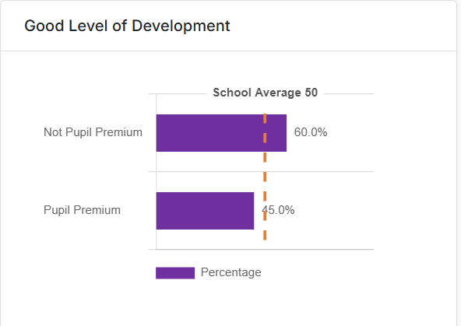
-20 pupils were in receipt of PPG. Fewer PPG pupils achieved a GLD in comparison to NPPG
pupils (15% difference).

Year 1 Phonics Screening Check (17 pupils PPG eligible)
9/17 PPG pupils passed the phonics screening check.
13/14 NPPG pupils passed the phonics screening check.
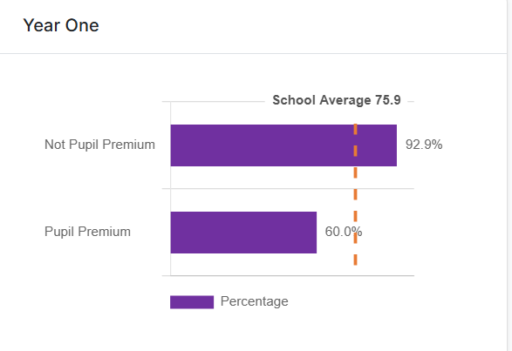75.9% was the % of pupils who passed the phonics screening check at the end of Year 1.
The average % for PPG pupils was 60%, 15% lower than the whole class average and 32%
lower than non PPG pupils.

END OF KEY STAGE 2- NOT PUPIL PREMIUM PUPILS (11)
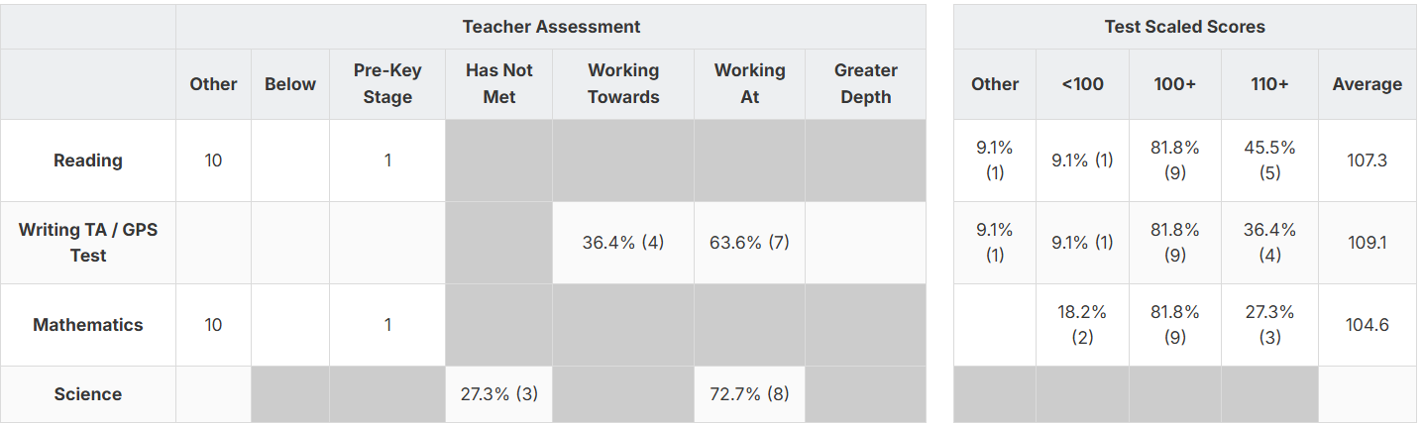
END OF KEY STAGE 2- PUPIL PREMIUM PUPILS (20)
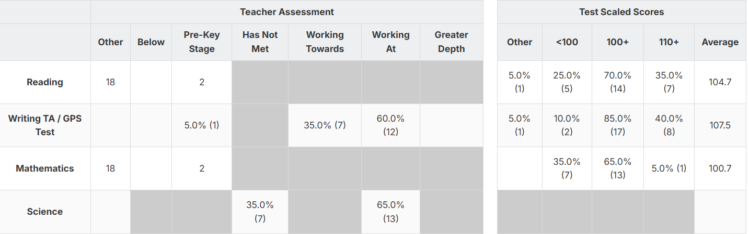

*NB- large group of PPG eligible pupils in previous Y6 class 20 as opposed to 11 NPPG
pupils.

-Looking at the Test Scaled Scores, more PPG pupils achieved at the expected or higher
standard than NPPG pupils in SPAG.
-More PPG pupils achieved the expected standard in the combined subjects- R, W & M (11)
than NPPG pupils (7)

Externally provided programmes
Programme | Provider
Lancashire Phonics Catch Up Intervention | Lancashire County Council
Unlocking Letters & Sounds | Ransom
IDL Literacy (online reading and spelling intervention) | IDL Solutions
Flying Start Project | Manchester LA

Service pupil premium funding (optional) N/A
Measure | Details
How did you spend your service pupil premium allocation last academic year?
What was the impact of that spending on service pupil premium eligible pupils?

Further information (optional)
- The success of the individual pupil premium interventions that lie beneath the activities noted above are described in detail on our Blue Hills Provision map. Staff who deliver the intervention/s are expected to set baseline and exit outcomes as well as completing evaluations after each session. This is overseen by the PPG lead, who regularly reviews the frequency of intervention delivery and the quality of the written evaluations. The provision map also costs each intervention so we can evaluate impact versus cost to determine if the intervention is worth repeating or a different approach is needed.
- Children Looked After or Previously Looked After also have their own funding cost centres and reports. Although many of them take part in the interventions listed in this statement, their parent/carers are contacted at least twice a year to inform them of what was spent and the impact of this expenditure in the previous academic year and to also ask them what they would like to purchase to support their child. Requests have included electronic devices to support home learning and payment for extra curricular activities such as swimming lessons.
- St Clements has been identified to receive targeted support from the Local Authority due being in an area that has high levels of deprivation. The Flying Start Project (started in September 23- July 26) aims to provide groups of schools with access to Educational Psychology, SALT, Early Help and Family Outreach worker services to develop staff skills and increase parental capacity.
- St Clements have been fortunate to again be awarded £15,000 from the Forgotten Forty (F40) Foundation in 2025-26 for a fifth year -sponsored by INEOS. This is due to the high percentage of pupils in receipt of a FSM in school. In 25-26, we intend to spend the award on financing educational visits and visitors to bring our curriculum to life and provide our pupils with experiences outside of their immediate locality that a number of them would not experience. Also, to allocate some of the grant to meet the increase in social and emotional needs that more pupils are experiencing.

