**Art /DT:**

**DT-** We will investigate a range of heathy snacks, design our own snacks using design criteria, make our own snacks and evaluate them.

**Art –** We will investigate the work of Yayoi Kusama, a Japanese artist who produces colourful work based on the natural world

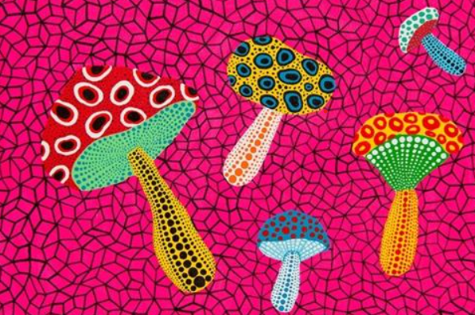

**ICT: Coding**

Children will be able to:

• Use different end blocks, including repeat forever;

• Change the size of characters to grow or shrink.

• Hide and show characters with an instruction block;

• Program two or more characters with

instructions at the same time.

**Humanities:**

**History – To** know about significant events in the lives of explorers from a range of different eras e.g. Christopher Columbus, and Neil Armstrong.

**Geography – Map Makers**

Children will find out what maps are and some of the different ways they are used. They will learn about the four compass points and use these to navigate around maps.

**Topic: Explorers**

**Year 2 - Autumn 2025**

**Numeracy :**

**Number and Place Value:** Numbers to 20

Count objects to 100 in tens

Recognise tens and ones

Partition numbers

**Calculations: Addition and Subtraction**

Number bonds to 10

Fact families to 20

Add and subtract ones

Add by making 10

Add to the next 10

Add three 1 – digit numbers

**Shape**

Recognise and draw 2D and

3D shapes

Count sides, corners, edges,

vertices

Sort shapes

Lines of symmetry

**Writing Opportunities:**

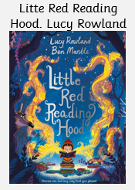

-Narative with an alernative ending.

-Character discription.

-Inner thought.

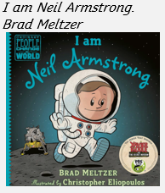

-Fact file

**Stories/Texts/links:**

Narrative: Imaginative Stories, Information Texts, Poetry, Instructions (linked with DT)

**Science:**

**Materials** -Identify and compare the suitability of a variety of everyday materials, including wood, metal, plastic, glass, brick, rock, paper and cardboard for particular uses

-Describe how the shapes of solid objects made from some materials can be changed by squashing, bending, twisting and stretching.

**Animals including Humans**- Living things need light, air and water to stay alive.

- Living things grow and change as they get older.

- All animals move, feed, grow, use their senses and reproduce.

- We need food to give us energy. We need food to grow. We need food to keep us healthy.

**PE and Music:**

Net Games – Striking for Accuracy

Invasion Games – Sending and receiving **Music: Music Express –** Ourselves,

Travel, Toys and Number

**RE:** Who is a Muslim and what do they believe? This investigation enables pupils to learn in depth from Islam, finding out about Muslim ways of life and beliefs, so that pupils can develop thoughtful ideas and viewpoints of their own about some religious and spiritual questions.