**Art /DT:**

**DT** – children will be designing and making a war time meal.

**Art –**Children will be looking at Blitz photos and creating their own version using a range of sketching techniques. Study of a war time artist or artist who depicted war.

**Humanities: Battle of Britain History/Geography Focus**

Children will be exploring the events leading up to the battle of Britain, understanding the lasting impact WWII has had on the World and comparing it to war since then, through to war today. Focus will be on the Blitz and ordering significant events throughout the war, including the “forgotten” heroes.

Children will also be looking at WW1 and other wars that Britain has fought in.

Map work will include European geography.

Children will also explore map work around the WWII countries and war torn countries today.

**Questions to investigate:**

How and why did the war begin?

Who invented air raid shelters and when?

What was the longest war?

How many wars have there been through history?

How did World War 2 finish?

What was the impact on life after (and during) the wars?

Did anything positive happen due to the wars?

Topic: Autumn 2025

World at War

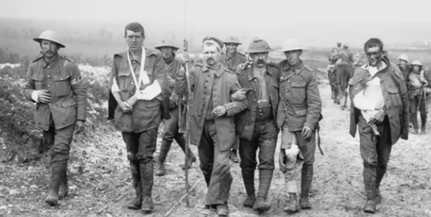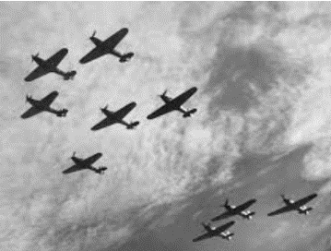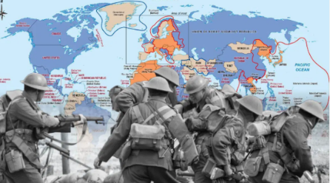

**MFL – French**

**French phonics**

**Presenting myself**

**My family**

**RE:**

**What do religions say when life gets hard?**

**Drama/S&L Opps:**

Throughout literacy unit – role play

**Stories/Texts/links:** Letters from the Lighthouse

Rose Blanche

War Game

Oranges in No Man’s Land

**Writing Opportunities:**

**All literacy this term will be directly linked to the topic.**

**Letter of persuasion**

**Journal entries**

**Poetry in the voice of WW2 children**

**Non- chronological report.**

**Narrative**

**PE and Music:**

**Dance: exploring War time dances**

**Outdoor Games: Team net games.**

**Music: Routes, journeys. Music from war era.**

**Numeracy Links:**

Throughout topic lessons children will be exploring measures through DT model building and rationing with proportion and ratio.

Children will analyse data and interpret graphs and tables related to war and WWII.

Numeracy will be linked through Science, History, Geography and Art and DT.

**ICT:**

**Code IT – children will be making their own games using previous skills they have learnt.**

**Research and E-Safety Awareness: children will be exploring the internet as a research tool as well as looking at the dangers and how to keep themselves safe online.**

**Science:**

**Electricity**

Children will be exploring circuits and symbols and discussing the dangers of electricity. They will discover problems and how to solve them.

**Light**

Children will be learning about the principles of light and shadows and their relationships to each other. Investigative skills and scientific enquiry will be throughout.