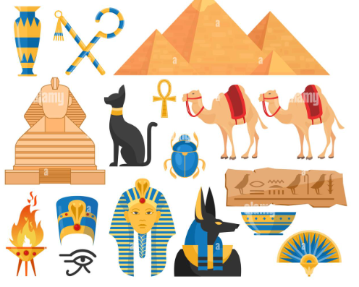
Year 3 Curriculum: Summer 2026
The Wonderful World of Ancient Egyptians

History:

In History we’ll be looking at the Culture and Beliefs of the Ancient Egyptians.

We’ll be comparing our ways of life with theirs and will develop our historical vocabulary.

We’ll also be looking at a variety of sources to learn as much as we can about this culture.

PE:

We will continue to develop skills in fitness and balance in our Fitness sessions. We will be practicing dance and Gymnastics.

-

Art /DT We will be examining Hieroglyphics and Egyptian Art, including clay work and pyramid building!

In DT, we’ll be looking at Ancient Egyptian cooking and making our own Egyptian meals.

Computing:

Presentation skills:
Word Processing and Powerpoint presentations.

Music: In Music we will be using percussion and IT to portray the Human Body, as well as understanding how we can communicate using music!

Writing Opportunities:
We will continue to develop our writing skills by creating a descriptive piece including description of character and setting. We’ll conclude our work with an information text.

Drama Opportunities:
Egyptian Gods and Goddesses.
Slaves building the pyraminds.

Drama opportunities linked to role play in RE and PSHE.

RE:
What does it mean to be a Christian in Britain today?

PSHE:
Keeping Safe and RSE

British Values – Individual Liberty and Rule of Law

Numeracy Links:
In Maths we will be working on the following:
Securing our knowledge of the four operations: addition, subtraction, multiplication and division.
We are trying to secure all of our times tables facts.

Science: Food and our bodies
Forces, including Magnetism
French: Fruits and vegetables, Ice-creams

