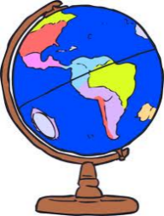
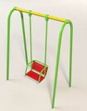
Humanities: Where in the UK
History/Geography Focus
Building on our knowledge of the local area, plot the countries within the United Kingdom. Learn about the different countries within the UK The rise of the British holiday.
Florence Nightingale – Who was she and what did she do?

Art /DT:
DT – Parks (moving parts)

Art –William Morris, repeated patterns and printing

Year 1 Summer Topic: Where in the world?
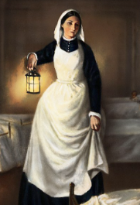
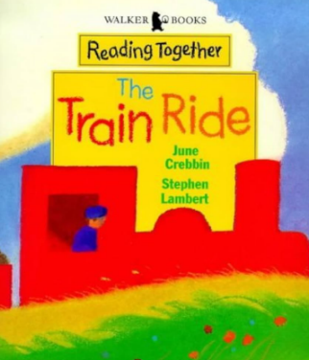
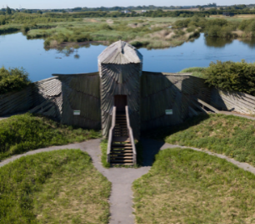
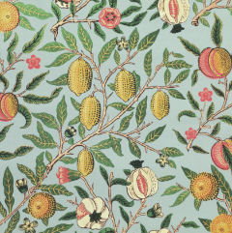
Science:
- Animals (including humans)
- Animal categories
- Omnivores, carnivores and herbivores
Seasonal Change
- Summer

ICT:
- Word processing
- Computer skills
- Creating pictures

Drama/S&L Opportunities:
Role Play: Scutari Hospital and Stories/Texts/links:
- The Train Ride
- Florence Nightingale

RE:
What does it mean to belong to a Faith Community?

Numeracy:
- Multiplication- counting in 1s, 2s, 5s and 10s
- Fractions
- Geometry- position and direction
- Place value (within 100)
- Measurement- money and time
- Writing numbers as words (to 100)

PE:
- Netball
- Athletics
- Fitness

Music:
Music Express Scheme- Story Time, Our Bodies, Travel and Water

Trips
Martin Mere Wetland Centre

St Clements Church

Writing Opportunities:
- Stories from different cultures
- Story Narrative
- Writing postcards
- Instructions – How to Make a Swing
- Biography for Florence Nightingale and a recount of the Lowry trip

