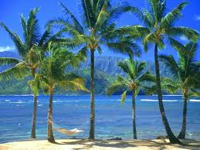
Year 2 Topic: Wild about Animals
Summer 1 & 2 2026
Art /DT:
Art- A Tropical Adventure with Henri Rousseau

DT -
Vehicles -Axles and wheels.

PE
Orienteering

Basketball

Athletics

Fitness
ICT: Computing

Getting to know IT – Basic skills
Word Processing

Creating Pictures

Humanities:
History – History of the seaside holiday
Geography - Polar and Tropical Regions.
Children are going to examine a globe and think about where the hottest and coldest places are.
They will consider why this might be and then look in more detail at these two habitats.

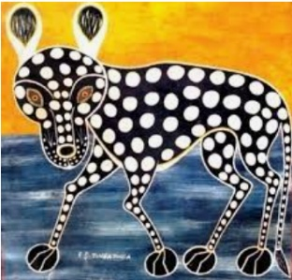



Writing Opportunities:

- Recount about Martin Mere Trip.
- Animal Poetry
- Setting description
- Story innovation.

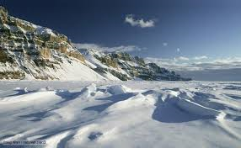
Music
Summer 1
Weather & Pattern

Summer 2
Water& Travel

D
RE: How should we care for others and the world, and why does it matter?
- What is special about our world?
- What can we learn from religions about deciding what is right and wrong?
- What matters most to Christians and Humanists?
- How and why should religious communities do more to care for the Earth?
- Does religion help people to be good?

Numeracy Links:

- Fractions
- Money
- Measurement
- Arithmetic: addition, subtraction, multiplication and division
Science: Living things and their habitats
Food Chains.
-All objects are either living, dead or have never been alive.
-Different habitats provide differing conditions for the animals that live there.
- Some animals are able to live in different habitats so you may find the same ones in different places.
- Within a habitat there are different micro-habitats.
- The plants and animals in a habitat depend on each other for food and shelter etc.
- The way that animals obtain their food from plants and other animals can be shown in a food chain.

