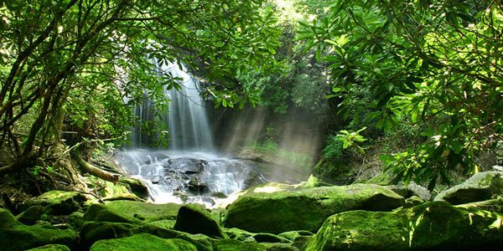
Questions children want to investigate:
What animals live in the rainforest?
What type of trees are in the rainforest?
What is the temperature in the rainforest?
What is the size of the rainforest?
How often does it rain?
Do humans visit the rainforest for holidays?
What insects live in the rainforest?
Are there any poisonous creatures in the rainforest?
How long could a human survive in the rainforest?

0
Geography focus:
The Rainforest
- What and where are rainforests?
- Name and locate South American countries
- Brazil / UK comparison – human and physical Geography
- Lines of latitude / longitude
- Rainforest weather report

Rainforests and Habitats Year 4
Summer 2026

Art /DT:
DT – Sewing creatures of the rainforest
Art – ‘Rubbish sculpture’ – recycled art

Writing Opportunities:
This term we will continue to write in a variety of genres including:
Extended stories
Information texts – rainforests
Texts inspired by the rainforest
We will also continue to practise our basic skills in all our lessons.
RE:
Children will be following our scheme and exploring:
What can we learn from Religions About Deciding what is Right and Wrong?

French
We will continue to learn French using speaking and listening and reading and writing skills for and In the classroom and What is the weather units?
Science:
- Changing state (from Spring 2)
- Living things and their Habitats
- Materials & their properties
Computing:
Our focuses this term will be:
- Communication – email and blogging
- Creating animations
PE and Music:
Swimming: lessons continue every Friday.
PE: is every Thursday and will cover orienteering, basketball and athletics.
Music: Group Ensemble Performance – recorders and other aspects such as singing and composing.

Maths:
This Term’s topics will be:
- Fractions
- Geometry – angles and triangles
- Shape, space and measure, including time and money
As well as this we will continue to practise our times tables, arithmetic and reasoning every day.

PSHCEE:
- Keeping Safe
- British Values – Mutual Respect, Tolerance for Diversity and Individual Liberty
- British Values – Respect for Diversity and Individual Liberty
- RSE

