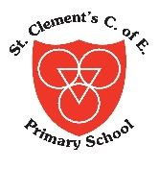
Before We Leave, We Will Achieve…..
 | 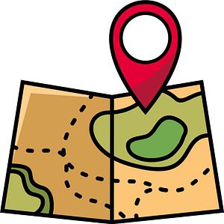  EXPLORING OUR WORLD & BEYOND OUR LOCAL AREA  (TRIPS & VISITS TO PLACES OF WORSHIP) |   TIME TO SHINE  (TAKE PART IN A PERFORMANCE) |   IT’S ART!  (WATCH A PERFORMANCE; WORK WITH AN ARTIST; VIEW ART) |   IN IT TO WIN IT  (ENTER A COMPETITION) |   ENTERPRISE & THE WORLD OF WORK  (UNDSTG MONEY MANAGEMENT & ENTERPRISE PROJECTS) |   NURTURE & RESPONSIBILITY (SENSE OF RESP FOR SELVES & WHERE THEY LIVE- EG CARE FOR A PLANT/S, ANIMALS) |   HELPING HAND  (SERVING SCHOOL & WIDER COMMUNITY- EG SCHOOL COUNCIL, MONITORS, PREFECTS, LITTER PICKS ETC)
YEAR 1 | Local Area – Park and Lime Square  Visit local supermarket to buy fruit for DT  Visit St Clements Church  Visit the Lowry  Visit Martin Mere Wetlands Centre  (Summer 2026) | Christmas Performance  Class Worship  Opportunity to take part in afterschool dance club with a performance for parents at the end of the course | Visiting Artist  Visit the Lowry  -Watch Christmas Pantomime  -Watch Drama Club Performance | Sports Day & other sporting competitions/extra curricular clubs  Science Week Poster | -Managing Money programme  -CLEMS Points- learning that if they save they will get better prizes  -Non uniform fundraising  -Macmillan Coffee morning  -Prepare & Cook a snack | -E-safety & e-safety team  -Road & water Safety  -Forest School  Martin Mere Tasks  Guardians of the Wild | Litter pick and recycling  Monitors for tidying up  -ICT Monitor  -Ethos team  Collection for School Harvest  -Agents of Change
YEAR 2 | -Local Area- Park  Looking at nature (in outdoor area)  -Visit St Clements Church  -Visit Staircase House (The Great Fire of London)  Visit Martin Mere Wetlands Centre  (Summer 2026) | Christmas  Performance  Class Worship – Great Fire of London  Visit to Staircase where the children have the opportunity to act out key events of The Great Fire of London | -Watch Christmas Pantomime  -Watch Drama Club Performance | Sports Day & other sporting competitions/extra curricular clubs  Science Week poster competition | -Managing Money programme  -CLEMS Points- learning that if they save they will get better prizes  -Non uniform fundraising  -Macmillan Coffee morning  -Prepare & Cook a snack  Collecting for Harvest Festival  Ice Cream Parlor virtual role play | -E-safety & e- safety team  -Road & water Safety  -Fire Service Visit  Planting seeds, planting and looking after plants in our outdoor environment | Agents of Change  Sports Councils (Health Champions)  Care of Outdoor Environment  Monitors for tidying up  ICT Monitor  Ethos Team  Litter pick and recycling  Planting seeds, planting and looking after plants in our outdoor environment

