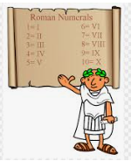
Questions children want to investigate:
- When was the Roman Empire at its height?
- What was life like in Roman Times?
- Where did people live in the Roman Era?
- Which Gods did the Romans worship?
- What made the Romans such efficient fighters and invaders?
- What did the Romans eat?
- Were the Romans like the Greeks?

RE:
Why do some people believe God exists?

PSCHEE
Mental and Emotional Health
Healthy Lifestyles
British Values

PE and Music:
PE: Net Games- Accuracy and Rallies
Invasion Games – Invasion in a Team (Hockey and Ball skills)
Music: Keeping Healthy
Our Community

Autumn term 2026 Year 5
Roman Life…
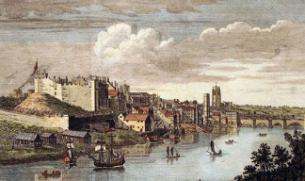
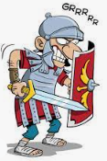
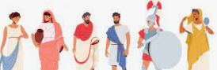
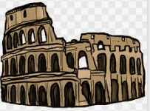
Science:
Materials Y5
Following on from their Y4 unit on Solids, Liquids and Gases, the children will experience a range of reversible and irreversible changes.
We will continue to focus on Working Scientifically by planning and carrying out our own investigations, collecting data and explaining our discoveries using scientific vocabulary.

Writing Opportunities:
We will be writing an extended narrative in our Literacy session, as well as applying the writing skills we are taught in different short write opportunities.

Drama Opportunities:
Hotseating, Roleplay,

Stories/Texts/links:
The Promise

Art /DT:
- Exploring the Romans’ use of mosaic, using these techniques to make mosaic artwork both traditional and modern.
- Design a healthy Italian menu, follow recipes, taste Italian food
Visits:
Roman
Chester
Numeracy Links:
- Place Value
- Four Operations (add, subtract, multiply, divide)
- Fractions

Computing:
Code I.T. - Coding and Programming - Game Design
- design, write and debug programs by breaking them into smaller parts.
- use sequence, selection and repetition in programmes.
- work with variables and various forms of input and output.
- use logical reasoning to explain how some simple algorithms work.
- detect and correct errors in algorithms and programmes.
- Design and evaluate a game using Scratch.

Curriculum links:
Discreet Subject
Geography Focus:
Geography will focus on the Roman Empire and its expansion throughout Europe, Asia and Africa.
We will compare the UK with Italy.
We will place the Celtic tribes on maps of the UK

History Focus:
Life in Roman times
The legacy of the Romans in Britain
Roman Gods and worship
Roman invaders
Comparing Ancient Rome and Ancient Greece

