Art /DT:
DT- We will investigate a range of heathy snacks, design our own snacks using design criteria, make our own snacks and evaluate them.

Art – We will investigate the work of Yayoi Kusama, a Japanese artist who produces colourful work based on the natural world
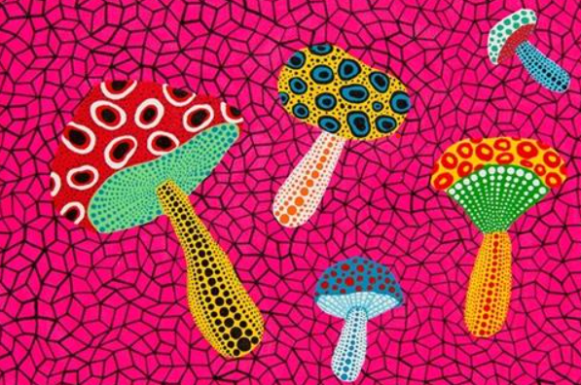

ICT: Coding
Children will be able to:
• Use different end blocks, including repeat forever;
• Change the size of characters to grow or shrink.
• Hide and show characters with an instruction block;
• Program two or more characters with
instructions at the same time.

Humanities:
History – To know about significant events in the lives of explorers from a range of different eras e.g. Christopher Columbus, and Neil Armstrong.

Geography – Map Makers
Children will find out what maps are and some of the different ways they are used. They will learn about the four compass points and use these to navigate around maps.

Topic: Explorers
Year 2 - Autumn 2026
Stories/Texts/links:
Narrative: Imaginative Stories, Information Texts, Poetry, Instructions (linked with DT)

Writing Opportunities:
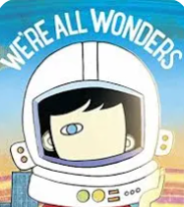

-Narrative
-Character discription.
-Inner thought.

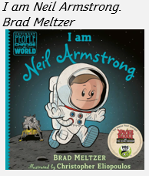
-Fact file

Numeracy :
Number and Place Value: Numbers to 20
Count objects to 100 in tens
Recognise tens and ones
Partition numbers

Calculations: Addition and Subtraction
Number bonds to 10
Fact families to 20
Add and subtract ones
Add by making 10
Add to the next 10
Add three 1 – digit numbers

Shape
Recognise and draw 2D and
3D shapes
Count sides, corners, edges,
vertices
Sort shapes
Lines of symmetry
Science:
Materials -Identify and compare the suitability of a variety of everyday materials, including wood, metal, plastic, glass, brick, rock, paper and cardboard for particular uses
-Describe how the shapes of solid objects made from some materials can be changed by squashing, bending, twisting and stretching.
Animals including Humans- Living things need light, air and water to stay alive.
- Living things grow and change as they get older.
- All animals move, feed, grow, use their senses and reproduce.
- We need food to give us energy. We need food to grow. We need food to keep us healthy.

PE and Music:
Net Games – Striking for Accuracy
Invasion Games – Sending and receiving Music: Music Express – Ourselves,
Travel, Toys and Number

RE: Who is Jewish and what do they believe? This investigation enables pupils to learn in depth from Judaism, finding out about Jewish ways of life and beliefs, so that pupils can develop thoughtful ideas and viewpoints of their own about some religious and spiritual questions.

