serving Jesus
Literacy:
We’ll be beginning our Literacy Journey with ‘The True Story of the 3 Little Pigs’ – followed by having a go at putting our own twists on famous fairy tales… we will be writing out own part of the story and also writing a persuasive letter!
Throughout the units we will be working on developing our year 3 writing skills and becoming even better authors!

Art /DT:
Art- Getting in Shape with Hundertwasser.
DT – Cooking.
Humanities: Geography Focus
European Focus: Explore Europe’s weather patterns and biomes, conduct fieldwork observations and measurements, identify continents and seas, use maps, symbols.
Study volcanoes: understand eruptions, magma, lava, formation, hazards, and impacts.
Autumn 2026
Topic: World Weather Year 3
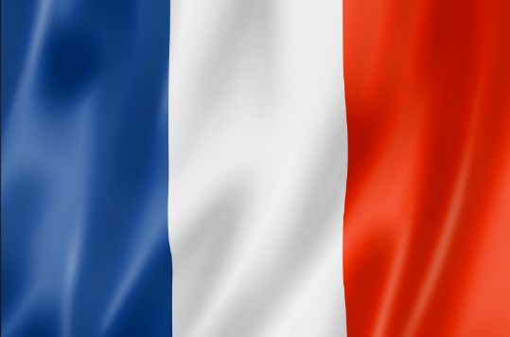
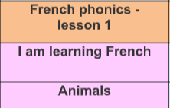
PE
Autumn 1 - Football, Handball and Fitness
Autumn 2 – Golf, Dodgeball and fitness.
Music
In the Past/Food and Drink

RE:
What do Different People Believe about God?
Bonjour!
French: Children will begin to learn the basics of French phonics. They will then take part in the following units:
Autumn 1 – We are Learning French
Autumn 2 - Animals
Writing Opportunities:
Fairy Tales (including twists!)
Diaries
Persuasive letters
Descriptive writing
We will also be answering comprehension questions to a high standard!
We will also be applying writing skills across the other subjects.

Oracy Opportunities:
We will be working on developing our Speaking and listening roles within classroom activities and trying to be ‘positive’ speakers and listeners.
We will be hot seating a character in our Literacy and getting in the roles of characters to explore their feelings.

ICT:
Code IT- Coding and programming.

Numeracy
Place Value to 100: Read, write, compare and order numbers; recognise hundreds, tens and ones.
Addition and Subtraction: Add and subtract 3-digit numbers using formal written methods and problem-solving.
Multiplication: Recall 3, 4 and 8 times tables; multiply and divide using known facts and practical methods.

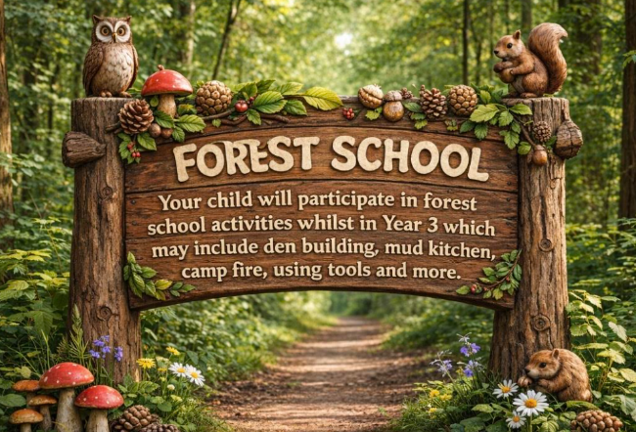
Science:
Rocks and Soils
Light and Shadows including:
-Sources of light – Natural vs Artificial
-Reflections
-Finding patterns in how shadows change shape and size

